Research Article

ANALYSIS OF AGROCENOSES IN THE UJAR REGION USING PHOTOMETRIC AND REMOTE SENSING METHODS

Rana Hasanova Baba-zada Alakbar¹, Shabnam Mammadova Aydin², Telli Jabiyeva Elshad³, Seyidnisa Aliyeva Khoshbakht⁴, Taybas Narirova Akhan²

¹Karabakh University, Republic of Azerbaijan, Khankandi
²Institute of Geography Public Legal Entity, Ministry of Science and Education, Baku, Azerbaijan Ministry of Science and Education of the Republic of Azerbaijan, Baku
³Azerbaijan University of Architecture and Construction, Republic of Azerbaijan, Baku
⁴Department of Geography of Azerbaijan and Geography Teaching Technology, Azerbaijan State Pedagogical University, Baku, Azerbaijan

*Corresponding author: rena.babazade@inbox.ru

ABSTRACT
This study, using satellite imagery and photometry, examined the current state of agrocenoses (soybeans and beans) in 2025 (May–September) and determined changes in vegetation cover across the entire Ujar district between 1987 and 2021. Data obtained from Landsat 5 and Landsat 8 satellites was processed in ArcGIS software, using the maximum likelihood classification method. The analysis revealed that over the past 34 years, the area of ​​water bodies has significantly decreased, while the area of ​​vegetation and residential areas has increased. At the same time, some agricultural land has become unproductive. These results provide practical recommendations for optimizing land management and environmental planning in the region and demonstrate the effectiveness of applying remote sensing technologies at the local level.

Keywords: Land cover, Landsat imagery, RS, satellite data, GIS analysis, classification, landscape dynamics

1. INTRODUCTION
Information on crop yield and production forecasts over large areas is essential for government agencies involved in food import and export, food security agencies, and domestic and international organizations monitoring food production and trade. The imbalance in global crop production due to crop failures in many countries has led to significant increases in agricultural prices. These events have sparked widespread concern about global agricultural production (Akhundova et al., 2025; Bakshakiyeva et al., 2020). The spectral characteristics and reflectance of plants generally depend on the optical properties of leaves, stems, and other elements, as well as their orientation and structure. As plants develop, their biomass increases, accumulating chlorophyll and other pigments, which in turn leads to changes in the absorptivity and reflectance of crops (Bunyatova et al., 2025; Chuvas et al., 2020). Changes in the luminance spectra of agricultural crops during their vegetation, despite general patterns, occur in different ways. The spectral luminance coefficient of all plants is almost identical during the first period of vegetation. Furthermore, reflectance depends on the volumetric density of phytoelements - crops with different vegetative masses have different spectral luminance (Gudmann et al., 2020; Gahramanova et al., 2026; He et al., 2023). Thus, the spectral luminance coefficient can be used to assess the physiological state of plants, monitor their development, determine the species composition of these communities, detect disease outbreaks, and predict crop yields. Land cover classification and analysis of long-term changes are important areas of research in modern landscape ecology and environmental management. In particular, processes such as the expansion of agricultural and residential areas, the modification of natural ecosystems, and land degradation have led to significant land cover changes (Ismayilov et al., 2025; Ismayilova et al., 2025a). Accurate assessment of these changes is possible thanks to modern technologies, including satellite imagery and remote sensing. Increased demand for biofuels, which require grain and oilseed crops, will increasingly compete with demand for food crops. Against this backdrop, the need for a state monitoring system for agricultural production is undeniable and has been included among the priority topics for the Ministry of Agriculture of the Republic of Azerbaijan (Ismayilova et al., 2025b; Jridi et al., 2023; Jalilova et al., 2024). Researchers have used a variety of methods to study land-use change over time. The most advanced methods include remote sensing, machine learning, and deep learning (Kulmatov et al., 2021; Macnunlu et al., 2025). In our study, we conducted the first land cover and landscape mapping in Azerbaijan using object-based image analysis and analyzed the impact of landscape metrics on improving the accuracy of land cover classification based on satellite imagery (Mammadova et al., 2026; Muradov et al., 2020). In the first time we analyzed land cover changes in the Ujar region of Azerbaijan, located in the Kur-Araz Lowland, from 1987 to 2021. This region, one of the country's strategically important agricultural areas, has been subject to anthropogenic impacts in recent decades. Therefore, our study provides important information for understanding land cover classification, regional landscape dynamics, and environmental impacts (Macnunlu et al., 2025). This study applied classification methods supported by remote sensing and GIS technologies. The results obtained can contribute to the development of sustainable land management strategies and provide a detailed explanation of landscape changes occurring in the area Mirzezadeh et al., 2025; Nasirova et al., 2025).
Study area: The Ujar district (Fig. 1) was chosen as the study site. Ujar is part of the Central Aran Economic Region and covers a total area of ​​830 km². The Ujar region is predominantly flat, with the lowlands located below sea level. An unmanned aerial vehicle (UAV) was used to create an orthophotomap of the study area. Aerial photography data was processed using the Agisoft Photoscan software. The aerial photography area covered 60 hectares. The resulting orthophotomap allows for the refinement of crop boundaries and acreage (soybeans and beans), monitoring of various crop types, and visual analysis of vegetation conditions. The use of UAVs in agriculture allows for real-time monitoring of the area while flying at altitudes ranging from a few centimeters to several hundred meters, while also obtaining photographic data (photometry). The obtained information serves as the basis for the creation of digital field maps in the form of orthophotos and vector plans; for farmland inventory; for crop condition monitoring; and for various vegetation indices (Ismayilov et al., 2025; Nasirova et al., 2026; Sadigov et al., 2025; Sadigov et al., 2026).
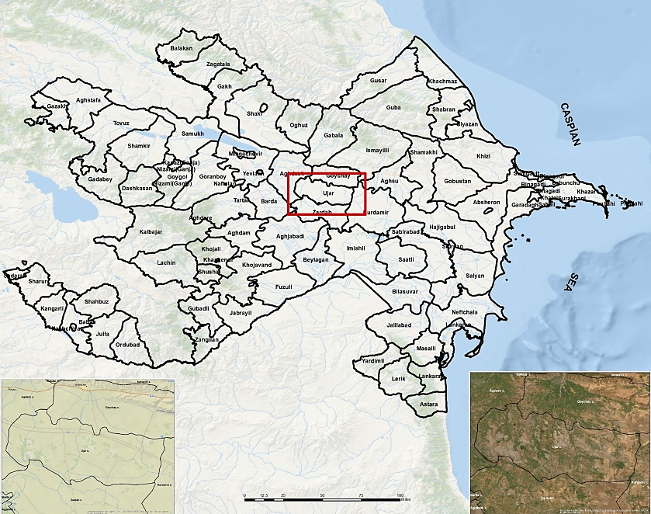
Fig. 1: Study area (Ujar region, Republic of Azerbaijan)

2. MATERIALS AND METHODS
The fact that saline soils cover vast areas of the Ujar region is one of the main factors hindering agricultural development. This requires the implementation of radical land reclamation measures in the region. The Ujar region plays a significant role in the country's economy due to its agricultural production. Although cotton and vegetable crops predominate, this sector has been giving way to grains and legumes in recent years. Multispectral images are a highly effective method for calculating environmental indices (Macnunlu et al., 2025). These images allow for the analysis of environmental elements based on their various reflectance properties. In the images, different objects - water, soil, and vegetation - are represented by different pixels. Each pixel is characterized by specific values, and these pixels are identified using a classification method. Classification methods come in two types: trained and untrained (Ismayilov et al., 2025). Both methods perform an automatic vectorization process, determining the most probable class of pixel values. Supervised classification: In supervised classification, the user selects test samples, generates a series of combinations, and applies these samples to all image pixels. The number and type of samples selected are determined based on the user's personal knowledge and experience, allowing for more accurate pixel selection. Unsupervised classification: In unsupervised classification, the user does not select example classes. In this case, the software automatically identifies related pixels and groups them into appropriate classes. This approach helps analyze environmental characteristics more efficiently and accurately (Fig. 2 a-b).
Satellite images were selected based on the fact that the two images were taken close together and there was no cloud cover over the study area. Several satellites provide images with varying spatial and temporal resolutions. Landsat data is one of the best sources for land use studies, being useful for land surface mapping, change detection, and monitoring (Fig. 2 c-d). When studying crops remotely, the possibility of counting plants is virtually impossible. Crop thinning is assessed indirectly through changes in the intensity and spectral composition of reflected radiation, caused by changes in the contribution of components of the soil-vegetation-shade system to the formation of this radiation (Gahramanova et al., 2026; Ismayilova et al., 2025a). More reliable reference values ​​are obtained by direct spectrometry of crops with varying sparseness in the test plot. It should be noted that crops belong to complex polychromatic geosystems. The spectral composition of radiation reflected at different angles relative to the vertical direction and the direction of the sun will change. Therefore, more complete information can be obtained, for example, from an aerial photograph of the test plot using image photometry. Similarly, areas with various plant lesions, damage, and lodging are studied. Lodging significantly alters the spectral reflectivity of crops (Mirzezadeh et al., 2025; Nasirova et al., 2025). The soil is almost completely covered by plants. The spectral composition of the reflected radiation is largely determined by plant stems. The surface structure changes significantly, and fragments of lodging crops appear differently. On conventional wide-field aerial photographs, such areas are reliably identified by their integral tone and distinctive texture.
A 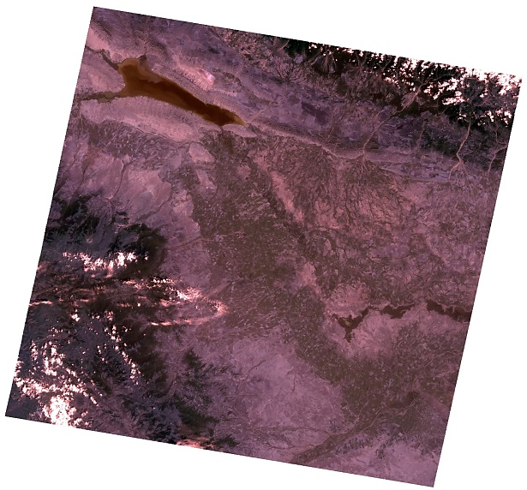B 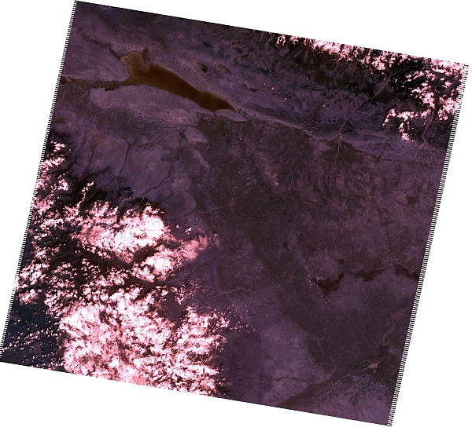
C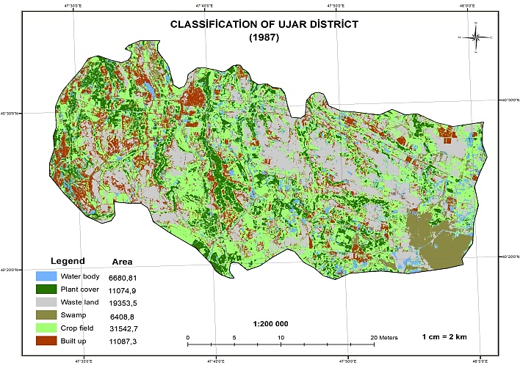D 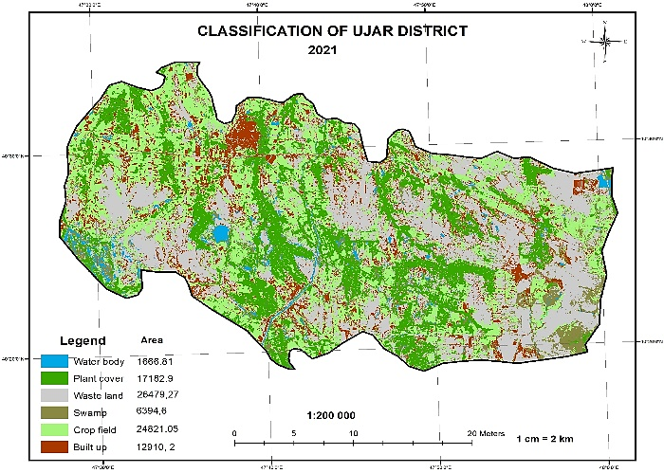
Fig. 2: Landsat 8 multispectral satellite images 1987 (A); 2021 (B); Maps obtained from training samples 1987 (C); and 2021 (D)
Table 1: Image database
Data collection attribute | Images
Data collection attribute | 1 | 2
Universal Reference Data System (URS) column | 166 | 166
URS line | 032 | 032
Filming date | 10/06/1987 | 30/07/2021
Number of intervals | 7 | 11
Exchange form | GEOTIFF/JPEG
Datum and ellipsoid | WGS 1984
UTM Zone | Zona 39

The obtained images were adapted to the study area since they covered a larger area. For this purpose, the images were cropped within the boundaries of the administrative district for both dates. Range combinations were used to make the objects more clearly visible. For training, image samples were taken and classification was performed using the maximum likelihood method. A process model was constructed, and the results were obtained through automated application (Fig. 3). The applied model was implemented as follows:
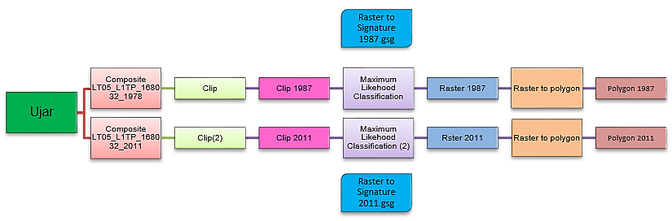
Fig. 3: Model of the structure of the processing process
3. RESULTS AND DISCUSSION
A significant advantage of phytopathological monitoring using imaging equipment over traditional ground surveys is that it allows specialists to obtain a more complete picture of the disease's distribution. This significantly simplifies the planning and organization of crop-saving efforts. Establishing proper order in this area will help preserve tens of thousands of hectares of highly productive land, primarily located in the most developed, cultivated areas of the land use. Classification was conducted using satellite imagery across six classes, resulting in two raster images (Fig. 4). As is well known, calculating areas from raster data is difficult, necessitating the need to transform the existing data. Using ArcGIS software (ArcToolbox, Conversion Tools, Raster to Polygon), each of the two raster files was converted into an area object (polygon). The area of ​​each classified object is presented comparatively in the following figures. The changes observed in the classification of satellite images over two periods (1987 and 2021) provide valuable insight into landscape dynamics. Let us analyze the trends observed in each land use class. The results obtained on the training samples show that the following changes were recorded in the Ujar district over 34 years: From 1987 to 2021, the area of ​​water bodies decreased from 6.68081 to 1.66681 ha. This represents a decrease in the area of ​​water bodies by approximately 75%. The area of ​​green spaces increased from 11.7049 to 17.1829 ha. This is an increase in green space area of ​​approximately 47%. The area of ​​unused land increased from 19.3535 hectares to 23.02437 hectares, which represents an increase of approximately 36%. The area of ​​wetlands decreased from 6.408 hectares to 6.3946 ha, but this decrease is insignificant. The area of ​​cultivated land decreased from 31.5427 to 24.82105 ha, which is approximately 21% of the total cultivated land area. The area of ​​residential areas increased from 11.0873 to 13.68742 ha. These changes indicate increased anthropogenic impact in the region and that land use changes have influenced the landscape structure of the area (Table 2).
Table 2: General classification indicators by classes
Classification | Satellite images
Classification | 1987 | 2021
Classification | Classification, ha
Water bodies | 6680.81 | 1666.81
Green area | 11704.9 | 17182.9
Useless area | 19353.5 | 23024.37
Swamps | 6408 | 6394.6
Agrocenoses | 31542.7 | 24821.05
Accommodation | 11087.3 | 12910.21
Total | 86777.21 | -

A 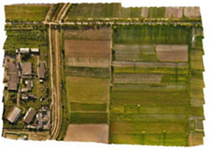B 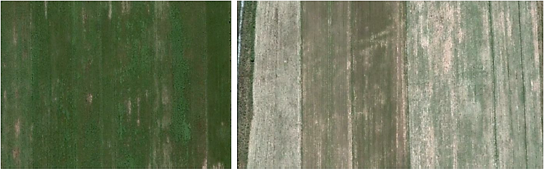
Fig. 4: Orthophotomap of selected agrocenoses (Soybean and Bean) based on UAV photography data (A) and satellite data in vegetation period (B) (08 August, 2025)
To visually interpret the satellite images, in addition to ground-based fieldwork, natural color composite images were used, corresponding to monthly NDVI images of agricultural crops (soybeans and beans). The growth and maturation process of different plant species has its own characteristics, related to the varying distribution of their green mass over time. Therefore, it is possible to differentiate vegetation types by studying vegetation index values ​​during different periods of the growing season, based on satellite images. Processing Landsat-5 and Landsat-8 multiband images for each month of the 2025 growing season allowed us to obtain NDVI images for each month for further classification. Land use classification, crop status determination, and land plot contouring, as well as photogrammetry, were completed using Landsat-5 and Landsat-8 satellite images (Fig. 5 a-f).
А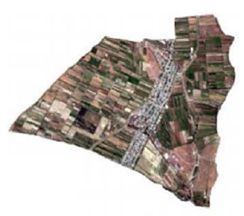B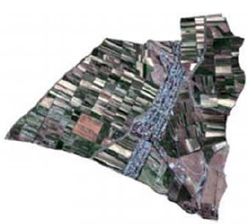
C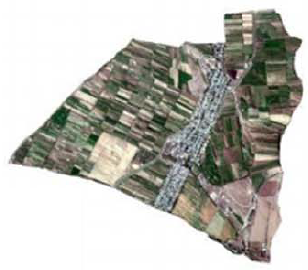D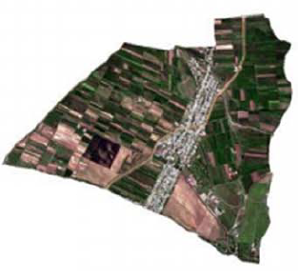
E 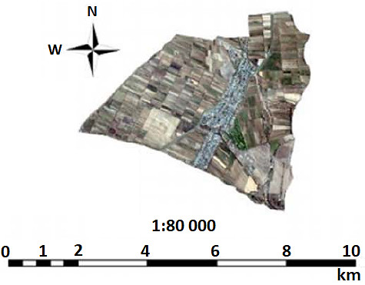 F 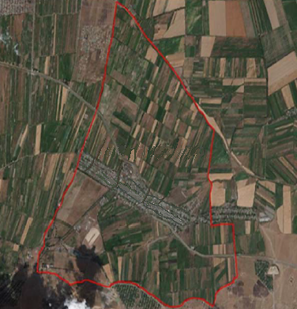
Note: May (A); June (B); July (C); August (D); September (E) months in 2025 year; Satellite image of selected agrocenoses area in region (F)
Fig. 5: Composite image of the Ujar region in natural color for the growing season of agrocenoses (Soybeans and beans)

5. CONCLUSION
Research has shown that remote sensing (RS) data can be used for effective agricultural management using modern methods of agricultural land monitoring based on vegetation indices. Landsat-5 and Landsat-8 satellite images are modern RS products with sufficiently high spatial, temporal, and radiometric resolution. Satellite images are now playing a particularly important role in environmental and crop research and monitoring. The selected study area was thoroughly studied during office and field work, which resulted in the refinement of land use boundaries and the compilation of a catalog of cultivated crops.

Declarations

Funding: This study did not get any financial support from any organization/agency.

Acknowledgement: The authors express their gratitude for the support of the scientific and technological research project to the Institute of Geography Public Legal Entity, Karabakh University. Also, for the equipment to Azerbaijan University of Architecture and Construction and Azerbaijan State Pedagogical University

Conflicts of Interest: All authors declare no conflict of interest.

Data Availability: All the data is available in the article.

Ethics Statement: This article does not contain any studies with humans/animals, thus requires no ethical approval.

Author’s Contributions: Rana Hasanova, Shabnam Mammadova and Telli Jabiyeva Elshad: Conceptualization, Supervision; Seyidnisa Aliyeva, Taybas Narirova, and Shabnam Mammadova: Data curation, Methodology, Supervision, Writing – original draft; Rana Hasanova, Shabnam Mammadova, and Taybas Narirova: Investigation, Validation, Visualization, Data curation, Formal analysis; Seyidnisa Aliyeva, Shabnam Mammadova and Rana Hasanova: Software, Validation, Writing – Review & Editing, Rana Hasanova, Shabnam Mammadova, Taybas Narirova, and Seyidnisa Aliyeva: Data curation, Verification, Writing – Editing. All authors have read and approved the final version for publication.

Generative AI Statements: The authors declare that no Gen AI/DeepSeek was used in the writing/creation of this manuscript.

Publisher’s Note: All claims stated in this article are exclusively those of the authors and do not necessarily represent those of their affiliated organizations or those of the publisher, the editors, and the reviewers. Any product that may be evaluated/assessed in this article or claimed by its manufacturer is not guaranteed or endorsed by the publisher/editors.

REFERENCES:

Akhundova, S. M., Mammadova, G. I., & et al. (2025). Study of the modern bio-ecological state of Absheron coastlines. Advances in Biology & Earth Sciences, 10(1), 168–176. https://doi.org/10.62476/abes.101168
Bunyatova, L. N., Mammadova, G. I., & et al. (2025). Main eco-properties of hazelnut (Corylus avellana L.) in the Sheki-Zagatala economic region. International Journal of Advances in Applied Sciences, 14(1), 77–85. https://doi.org/10.11591/ijaas.v14.i1.pp77-85
Bakshakiyeva, K. F., Namazov, N. R., & et al. (2020a). Ecophysiological features of toxigenic fungi prevalent in different biotopes of Azerbaijan. Biointerface Research in Applied Chemistry. 10(6), 6773 - 6782. https://doi.org/10.33263/BRIAC106.67736782
Bakshakiyeva, K. F., Cabrayılzadə, S. M., & et al. (2020b). The General Characteristic of Anamorphic Fungi Spread In Azerbaijan. International Journal of Recent Technology and Engineering (IJRTE). 8(3), 2208-2211. 10.35940/ijrte.C4591.098319
Chuvas, E. D., Picoli, C. A., & et al. (2020). Recent applications of Landsat 8/OLI and Sentinel-2/MSI for land use and land cover mapping: A systematic review. Remote Sensing, 12(18), 3062. https://doi.org/10.3390/rs12183062
Gudmann, A., Csikós, N., & et al. (2020). Improvement in satellite image-based land cover classification with landscape metrics. Remote Sensing, 12(5), 99-112. https://doi.org/10.3390/rs12050999
Gahramanova, A. Y., Mammadova, R. N., & et al. (2026). Studies on gray-brown soils with rapeseed (Brassica napus L.) as a forage crop in the Sheki region of the Greater Caucasus. SABRAO Journal of Breeding and Genetics, 58(1), 432–441. http://doi.org/10.54910/sabrao2026.58.1.40
He, Y., Zhang, Z., et al. & et al. (2023). Monitoring salinity in bare soil based on Sentinel-1/2 image fusion and machine learning. Infrared Physics & Technology, 131, 104656. https://doi.org/10.1016/j.infrared.2023.1
Ismayilov, A. I., Hasanova-Babazade, R. A., & et al. (2025). Soil salinization in Ujar region of Azerbaijan with index application and comparison of various methods. Comptes Rendus de l'Académie Bulgare des Sciences, 78(6), 946–954. https://doi.org/10.7546/CRABS.2025.06.18
Ismayilova, A., Shukurov, S., & et al. (2025a). Modern soil cover of natural cenoses and agrocenoses landscapes of the Kur-Araz plain. Advances in Biology & Earth Sciences, 10(2), 314–325.
https://doi.org/10.62476/abes.102314
Ismayilova, A. A., Mirzezadeh, R. I., & et al. (2025b). Biomass and enzymatic activity assessment of the coniferous-deciduous forests in Azerbaijan. SABRAO Journal of Breeding and Genetics, 57(6), 2584–2595. https://doi.org/10.54910/sabrao2025.57.6.31
Jridi, L., Kalaitzidis, C., & et al. (2023). Quantitative landscape analysis using Earth-observation data: An example from Chania, Crete, Greece. Land, 12, 999. https://doi.org/10.3390/land12050999
Jalilova, A., & Hasanova Baba-zade, R. (2024). The influence of global climate change on the hydromorphological regime of river waters in the Sabirabad and Ujar regions. Proceedings of the 6th International Scientific and Practical Conference “Scientific Goals and Purposes in XXI Century”, Seattle, USA, 380–386. https://doi.org/10.51582/interconf.19-20.03.2024.037
Kulmatov, R., Kahsanov, S., & et al. (2021). Assessment of the space-time dynamics of soil salinity in irrigated areas under climate change: A case study in Sirdarya Province, Uzbekistan. Water, Air, and Soil Pollution, 232(5), 155–158. https://doi.org/10.1007/s11270-021
Macnunlu, K., Hasanova Baba-zade, R., & et al. (2025). Ecological sustainability of agroecosystem and productivity assessment in the Barda area using NDVI and SAVI. Advances in Biology & Earth Sciences, 10(1), 148–157. https://doi.org/10.62476/abes.101148
Mammadova, R. N., Salimova, S. J., & et al. (2026). Plant leaves as a biogeochemical indicator of the environmental state in different regions of Azerbaijan. Comptes Rendus de l'Académie Bulgare des Sciences, 78(11), 1601–1610. https://doi.org/10.7546/CRABS.2025.11.03
Muradov, P. Z., Gasimova, G. Ch., & et al. (2020). Comparatıve study of mycobıota of some relıct plants included to the flora of Azerbaıjan. Journal of Complementary Medicine Research. 11(2), 227-231. https://doi.org/10.5455/jcmr.2020.11.02.30
Mirzezadeh, R. I., Ramazanova, F. M., & et al. (2025). Assessment of variations caused by biological activities in the Greater Caucasus forest soils used for agriculture. SABRAO Journal of Breeding and Genetics, 57(4), 1634–1643. https://doi.org/10.54910/sabrao2025.57.4.29
Nasirova, A. I., Isagova, V. G., & et al. (2026). Changing the biological activity of soil in sunflower crops. Comptes Rendus de l'Académie Bulgare des Sciences, 79(1), 145–156. https://doi.org/10.7546/CRABS.2026.01.18
Nasirova, A. I., Hasanova, T. A., & et al. (2025). Modeling of soil electrical conductivity for sustainable land use in salinized areas. Agrarian Bulletin of the Urals, 25(8), 1199–1208. https://doi.org/10.32417/1997-48682025-25-08-1199-1208
Sadigov, R. A., Alverdiyeva, N. F., & et al. (2026). Current state of production of alternative energy on the Absheron Peninsula. International Journal of Applied Power Engineering, 15(1), 37–45. http://doi.org/10.11591/ijape.v15.i1.pp37-45
Sadigov, R. A., Nazarova, M. K., & et al. (2025). Modern research on the use of alternative energy resources in Azerbaijan. International Journal of Advances in Applied Sciences, 14(3), 907–915. https://doi.org/10.11591/ijaas.v14.i3.pp907-915
Shukurov, S. K., Ismayilova, A. A., Sadigov, R. A., et al. (2025). Determination of soil salinization by hyperspectral remote sensing in the Shirvan Plain. International Journal of Advances in Applied Sciences, 14(3), 662–670. https://doi.org/10.11591/ijaas.v14.i3.pp662-670
Verdiyeva, F. B., Hasanova, T. A., & et al. (2025). Bioecological characteristics of modern soil cover in subtropic regions of Azerbaijan. International Journal of Advances in Applied Sciences, 14(4), 113–121. https://doi.org/10.11591/ijaas.v14.i4.pp113-121

